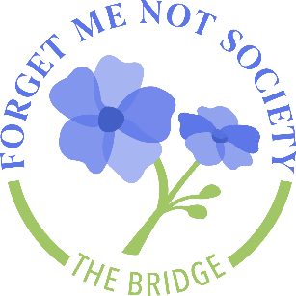
I would like to become a Founding Member of The Bridge Alzheimer’s & Dementia Resource Center Multiple-Year Giving Society:
PLEDGE FORM
“Creating a community where no one affected by Alzheimer’s and dementia makes the journey alone.”

$_______________ per year for _____________ years

Payment:
_____My check is enclosed made payable to: The Bridge Alzheimer's & Dementia Resource Center
_____Please charge my credit card
Credit Card #__________________________________________________________________________
Name on card_________________________________________________________________________
Exp. Date______________________ *Zip______________________ *CVV________________________
*Credit Card billing address if different from home address:
____________________________________________________________________________________
_____Please contact me about paying my pledge with stock.
_____My company will match my gift.
We will bill you in August for your annual pledge, unless you request otherwise.
Signature: ___________________________________________________________________________

Date_________________________________________________________________________________
Name ________________________________________________________________________________
I/We would like to be acknowledged (please print)
Organization___________________________________________________________________________
Address______________________________________________________________________________
City, State, Zip_________________________________________________________________________
Day Phone_______________________________Evening Phone_________________________________
Email Address_________________________________________________________________________

